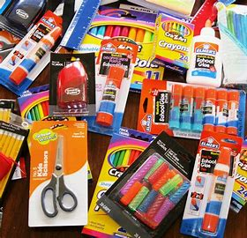JWood Raw 1st Grade Supply List

We are so excited to welcome you to a new year at a new school! Please contact us if you have questions or need help with the supplies. Please don’t label any items. Please remove packaging to help us save time.

Thank you!

* 2x 2-pocket poly/plastic folders
* Box of crayons (Max size 24)
* 2 packages of glue sticks
* 8 black Expo dry erase markers (chisel tip)
* 1 container sanitizing wipes or baby wipes
* Hand sanitizer
* Ziploc bags – any size
* 1 pack of black fine tip markers
* 1 small pack of markers
* Kleenex boxes
* Kid scissors
* 4 boxes of Ticonderoga pre-sharpened pencils
* $40 class fee to cover items teacher will purchase throughout the year. (Please enclose money in a sealed envelope with your child’s name on the outside).
* Backpack for your child (labeled with your name)

